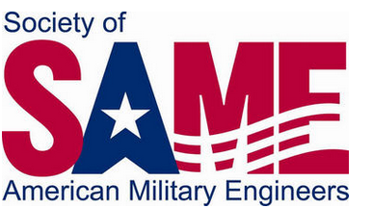  16th annual kittyhawk post industry day  When  Thursday, June 30, 2016  8:00am-4:30pm  Where  Hope Hotel & Holbrooke Conference Center  10823 Childlaw Rd, Wright-Patterson AFB, OH 45433  Hotel entrance is located right before WPAFB Gate 12A  theme  Engineering Challenges in healthcare  Featuring speakers from:  ►VA  ►mOUNT cARMEL hEALTH  ►US Army Corps of Engineers  ►88th Med Group  ►VISN 10  ►sHNEIDERS gLOBAL sOLUTIONS |  |  | LUNCHEON  11:30 am to 1:00 pm  Featured Speaker Glenn Costi, CEO for Dayton VA  Available Booths  Limited number is available at $200 each. Cost includes one full registration.  BOOTH RESERVATIONS AND INFO  Kirsten Evans  (614) 923-3930  kevans@metrocdengineering.com  Attendee registration details to come at  samekittyhawkpost.org

